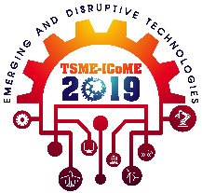
Abstract Template for the 10th TSME-ICoME (1 page only)
The 10th TSME International Conference on Mechanical Engineering
10th – 13rd December 2019
Pattaya, Thailand

AECXXX
(this number will be assigned after full manuscript is accepted)

F A Author¹, S B Author², and T C Author^{1,*}
¹Academic or Business Affiliation, Address, City, Zip Code, Country
²Academic or Business Affiliation, Address, City, Zip Code, Country

* Corresponding Author: E-mail
Abstract. These instructions give you guidelines for preparing a full manuscript for the 10th TSME International Conference on Mechanical Engineering. If you can open this file in Microsoft Word, you can use it as a template. Otherwise, use this document as an instruction set. The submitted manuscript must conform to this format in order to be published in the conference proceeding.
Keywords: Provide 3 – 5 keywords related to your paper for indexing of the article.

